

INTEGRATION INSTALLATION OVERVIEW

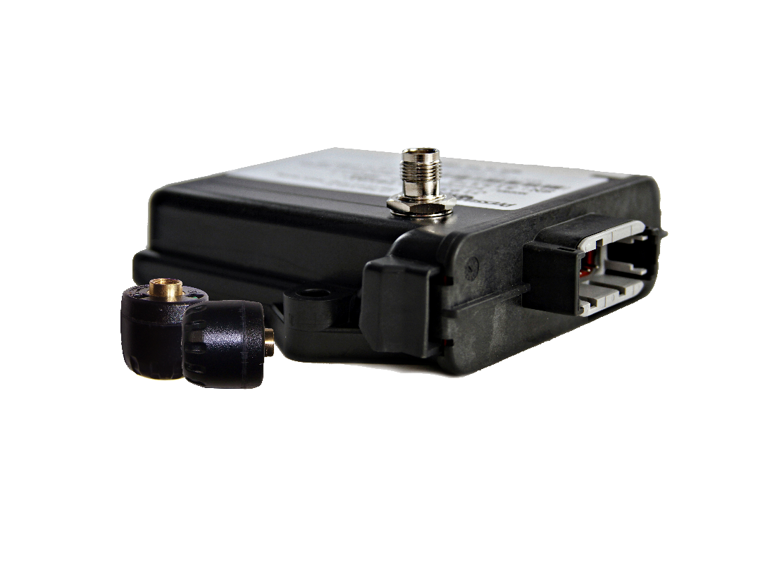

Founded in 1991, PressurePro has lead the innovation and advancement of the TPMS market for over three decades. Noted as the pioneers in Tire Performance Management, we remain unwavering in our dedication to add safety and savings for drivers and fleets of all types. Today, we are proud to remain the Global Standard in TPMS, providing fleets around the world with the market’s most tested and trusted solutions, which remain designed and manufactured in the USA.

In this Integration Installation Overview manual, you will find installation steps for multiple integrated installation options for LINK devices, on both tractor and trailer. Two programming methods are also included. Please refer to the guide below to locate your appropriate overview(s):

LINK INSTALLATION:
Tractor Installation:
- J1939 (9-PIN) Integration – Page 3
- RP1226 Integration – Page 4
Trailer Installation:
- Universal Repeater Install – Page 5
- Samsara AG26 / AG53 Install – Page 6

PROGRAMMING:
- Flex I/O – Pages 7-9
- PULSE – Page 10

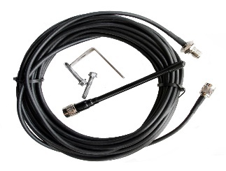
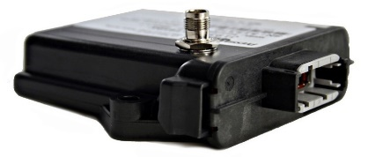

LINK and Coax Cabled Antenna Kit

PressurePro is a wireless electronic Tire Performance Management Solution (TPMS) that is designed to display current tire pressures on demand, whether moving or stationary. PressurePro systems, which can be used on all pneumatic tires, consists of two basic components: Tire Sensors which screw onto the valve stems of the tires, and a display or gateway, which sits in-cab or under-dash. PressurePro will not prevent tires from losing pressure or failing, but it can provide early notice of potential problems and alert to low tire pressure situations. Because of the quirks of RF Transmissions and interference, no guarantee of signal reception can be made. PressurePro is not meant to function as a pressure gauge.

2
J1939 (9-PIN) OVERVIEW

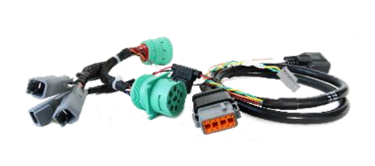
Connect LNK-250K to J1939:
Select a location behind the dash that allows the LINK Cable (3 ft.) to reach the J1939 access point.

Connect the female 9-pin, on the LINK cable, to the trucks male 9-pin. If you have other solutions using the 9-pin port, you can connect them in-line using the male 9-pin on the LINK cable.

CAN Selection: On the LINK cable, you’ll see 3 pig tails for different CAN options. Using the male 2-pin connector (Green & Yellow wires), you’ll connect this to the desired CAN network on the female 2-pin plugs.
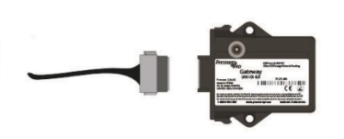
Mount LNK-100/LNK-101:
The LINK device will live near the J1939 port.
Place away from any obstructions. Use best judgement securing cables and wires.
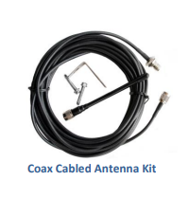
Attach and ‘Run’ Cable Antenna:
The coax cable should be run into the cab through the firewall and connected to the LINK device. Route the cable along other wires and hoses underneath and back to a rear cross member.
(Zip-tie frequently to prevent “wear and tear”.)

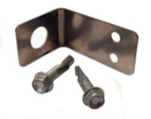
Mount Whip Antenna:
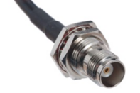
Select a centralized, metal, mounting location as far back as possible (typically a rear cross-member or sub-frame) and secure ‘L’ tightly, ensuring proper ground. Secure TNC connector to ‘L’ bracket, then attach whip antenna to TNC connector, pointing down. *Note, PressurePro recommends pre-drilling holes or your ‘L’ bracket and securing with nut and bolt combo.
Mounting Bracket
TNC Connector

Install Sensor to Valve Stems:
Once LINK is mounted/powered, and your antenna is run, you’re ready to program and mount sensors onto your valve stems. Note: Unless you opted to have your Sensors pre-programmed, do NOT place Sensors onto valve stems until programmed/during programming. See Flex I/O or Pulse programming section for next steps.

3
RP1226 OVERVIEW
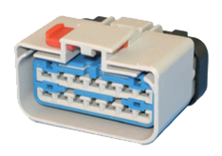
Connect LNK-205PD to RP1226 Port:
The RP1226 connector is located on the left-hand side of the steering wheel behind the dash near the Diagnostic connector.

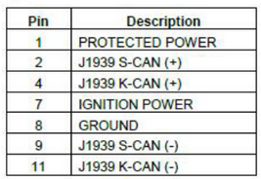
There will be multiple CAN bus speeds available
K-CAN for 125kbps and S-CAN for 500kbps. The LNK-205PD will have C & D CAN wires that will need to be inserted into the RP1226 connector on the LINK cable. The PIN locations will match the C & D wires from the truck’s RP1226.
Mount LNK-100/LNK-101:
The LINK device will live near the RP1226 port.
Place away from any obstructions. Use best judgement securing cables and wires.

Attach and ‘Run’ Cable Antenna:
The coax cable should be run into the cab through the firewall and connected to the LINK device. Route the cable along other wires and hoses underneath and back to a rear cross member.
(Zip-tie frequently to prevent “wear and tear”.)

Mount Whip Antenna:
Select a centralized, metal, mounting location as far back as possible (typically a rear cross-member or sub-frame) and secure ‘L’ tightly, ensuring proper ground. Secure TNC connector to ‘L’ bracket, then attach whip antenna to TNC connector, pointing down. *Note, PressurePro recommends pre-drilling holes or your ‘L’ bracket and securing with nut and bolt combo.
Mounting Bracket
TNC Connector

Install Sensor to Valve Stems:
Once LINK is mounted/powered, and your antenna is run, you’re ready to program and mount sensors onto your valve stems. Note: Unless you opted to have your Sensors pre-programmed, do NOT place Sensors onto valve stems until programmed/during programming. See Flex I/O or Pulse programming section for next steps.

4
UNIVERSAL REPEATER OVERVIEW

T-Breakout Trailer Cable (LNK-210PD):
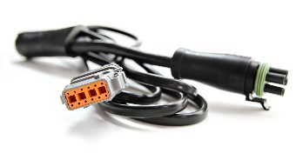
The LINK ABS T-Breakout Cable is used for powering LINK UR units. The T-Breakout plugs into the Trailers ABS Harness 5-pin WeatherPack connector, allowing quick and easy powering. NOTE: If you need to hardwire the LNK-210PD, use BLACK for Power and WHITE for Ground.

PressurePro recommends providing strain relief on all LINK UR installs. This is accomplished via U-bolt to all cables within 1 foot of the connector.

Connect LNK-210PD to ABS Harness 5-PIN:
If the trailer has an ABS system, use the LINK ABS T-Breakout Cable for power and data transmission. The ABS line will have a WeatherPack connector where the ABS splits out to the various brakes near the trailer axles. Separate the male and female shroud of the WeatherPack and connect to the appropriate ends of our T-Breakout.

If there is no ABS system on the trailer then use the LINK Blunt Cut Power Cable, or the T-Breakout can be cut for hardwiring. The LINK UR power cord will be wired via black wire to ground, and the red wire to trailer’s “constant hot” power line.

Mount LNK-210PD and Attach Whip Antenna:
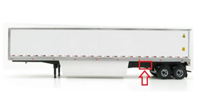
Attach the 6” whip antenna to the LINK UR and physically mount it on the underside of the trailer just forward of the rear axles (approximately 3’ to 8’) in a position where the attached antenna is not in contact with metal and where line-of-sight Sensor signals will not be blocked by the trailer’s underside structure.

Once LINK is mounted/powered, and your antenna is run, you’re ready to program and mount sensors onto your valve stems. Note: Unless you opted to have your Sensors pre-programmed, do NOT place Sensors onto valve stems until programmed/during programming. See Flex I/O or Pulse programming section for next steps.

5
SAMSARA AG26 / AG53 OVERVIEW

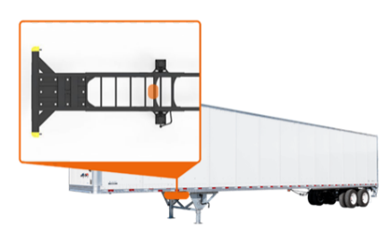
Mount LNK-100:
The typical mounting location for the LNK-100 is toward the front of the trailer, on the bottom side, tucked inside the frame rail of the trailer. Utilize self-tapping screws and the built-in mounting holes on the LNK-100 to attach it to the frame with connectors facing downward.

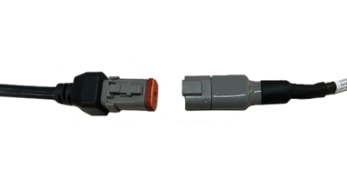
Connect CBL-AG-ATPM to LNK-204PD:
Locate both Samsara’s CBL-AG-ATPM 4 pin cable
and PressurePro LNK-204PD cable. Connect the
CBL-AG-ATPM 4 pin to the LNK-204PD 4 pin, ensuring to push the 4 pins together until you
hear a click. Secure excess cable length to
frame or existing cabling using zip ties.
Note* Ensure to avoid any pinches in cable.
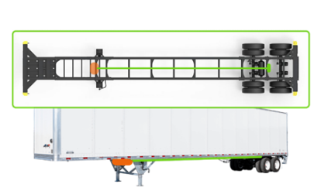
Attach and ‘Run’ Cable Antenna:
Attach (thread) TNC end of coax cable to mounted LNK-100. Once attached, ‘run’ cable along trailer frame toward back rear tires, securing cable with zip ties. Note* Ensure to avoid any pinches in cable.

Mount Whip Antenna:
Select a centralized, metal, mounting location as far back as possible (typically a rear cross-member or sub-frame) and secure ‘L’ tightly, ensuring proper ground. Secure TNC connector to ‘L’ bracket, then attach whip antenna to TNC connector, pointing down. *Note, PressurePro recommends pre-drilling holes or your ‘L’ bracket and securing with nut and bolt combo.
Mounting Bracket
TNC Connector

Once LINK is mounted/powered, and your antenna is run, you’re ready to program and mount sensors onto your valve stems. Note: Unless you opted to have your Sensors pre-programmed, do NOT place Sensors onto valve stems until programmed/during programming. See Flex I/O or Pulse programming section for next steps.

6
FLEX I/O PROGRAMMING GUIDE

Step 1: While connected to internet, connect your programming cable (JMP-400D, RS232 to USB jumper) to computer.

Step 2: Download PressurePro’s FLEX/IO Program Application.
Visit http://pressurepro.us/FlexIO and click ‘Download Here’ to download the ‘zipped’ Flex I/O application folder.

Open the downloaded zip folder and save the full ‘FlexIO Programmer’ folder to your desktop. (To extract the files, you’ll right click on the zip folder, then select “Extract All”. You’ll be asked to select a file destination for the extracted files.)

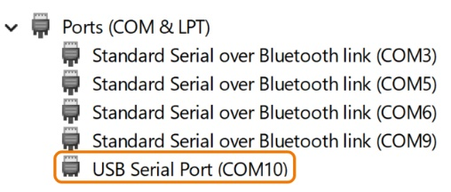
Step 3: Verify COM Port
In your computer’s search bar, search for and open ‘Device Manager’. Once in device manager, select ‘Ports’. Locate Port named either ‘Prolific’ or ‘USB Serial Port’ (which denotes the correct Port to select).

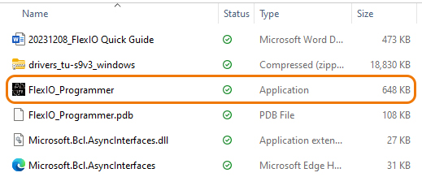
Step 4: Open FlexIO Programmer Application.
Double click on ‘FlexIO Programmer’ folder and open the FlexIO_Programmer.exe (has a black icon and the file type of ‘Application’).

Step 5: Go to vehicle/unit and power LINK Device.

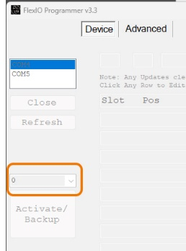
Step 6: Select Appropriate COM port and Activate Backup.
Select appropriate COM port from listing and click ‘Open Port’ button. LINK information will auto populate. Click Activate/Backup button.

Note* When programming for a tractor or trailer-only install, select ‘0’ from the drop-down menu directly above Activate/Backup button. For programming of trailers in drop-and-hook installations, select ‘1’ from the drop-down menu.

After Activation, LINK device data table and settings will automatically populate.

7
Step 7: Select you Vehicle/Unit Layout and Program Sensors:
Select your approproate vehicle/unit layout from the ‘Select Layout’ dropdown on the top, right hand side of your FlexIO Programmer Application and click ‘Update Settings’ button. Note* If your appropriate layout isn’t selectable, you can manually enter positions. Please reference sensor position numbering table below.

To program sensors, select a sensor to program from the data matrix trable by clicking on the row/slot. When a sensor is selected, edit the sensor values (including position, serial number and reference pressure) in the text fields above the data table. Once Sensor data is entered, click ‘Add’ button. Repeat sensor programming steps for each location/sensor.

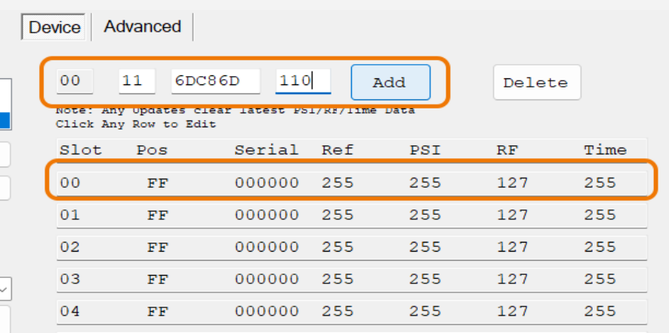

Sensor Position Layout Example

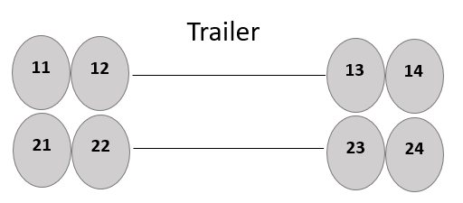
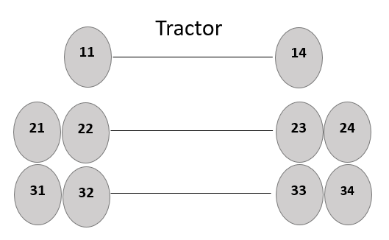
Your driver’s side, front wheel will always be the layout starting point. If the axle only as 2 wheels, the furthest right wheel must end with a 4 (as pictured below). The first number of as the axle, the second number will be the sensor position.

If you opted to have your sensors pre-programmed, please see layout chart sent with your programmed units. Note: Your sensors will labeled with position number stickers.

8
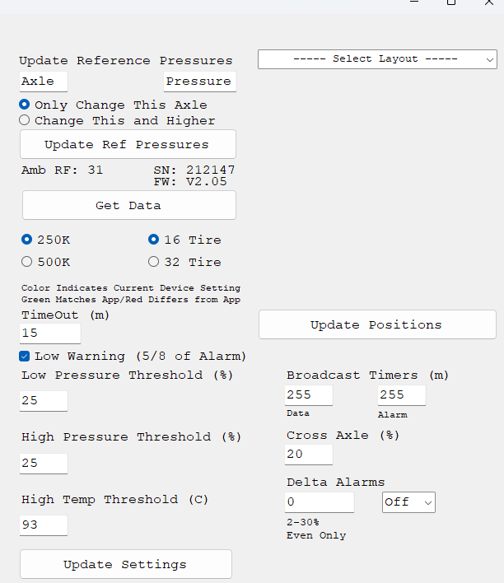
Settings Overview:

The FlexIO Programmer offers users the ability to make changes to settings on your LINK device.

To the right of the sensor data table, you’ll notice several customizable settings that allow you to change reference pressures, LINK baud rate, alert settings and more.

Any setting listed can be changed by selecting (or typing in) the desired setting then pressing ‘Update Settings’ button.

Settings Update Overview:

Reference Pressure: Type desired pressure in the Axle number & desired pressure. Click ‘Update Ref Pressures’ button to lock in updated settings.

Baud Rate: Select the desired Baud Rate. Click ‘Update Ref Pressures’ button to lock in updated settings.

Tires: Select the desired number of tires. Click ‘Update Ref Pressures’ button to lock in updated settings.

Alert Settings: Input the desired alarm settings (including low, high and high temp and cross axle thresholds and toggling on and off delta alarm). Click ‘Update Ref Pressures’ button to lock in updated settings.

9
PULSE PROGRAMMING GUIDE

COMPLETE PULSE INSTRUCTION AND USER MANUAL INCLUDED SEPERATELY.

The LINK units retain the location, Sensor ID, and reference pressure of each tire on the tractor (LINK HD/LT) & trailer (LINK UR) after powering down. All tire information is communicated through the LINK HD/LT to the CAN Bus.

Programming:
Can be accomplished over the vehicle’s diagnostic port or through the private network cable.
- Plug the 6-pin connector into PULSE.

- Plug the 9-pin or OBDII Connector into the diagnostic port. (To use the private network cable power via cigarette lighter in the truck.)

- Ensure the PULSE is in Drop and Hook mode:
  - MENU → DISPLAY → ADVANCED → OPERATION MODE → select “DROP AND HOOK” → SEL (follow command prompts for reboot)

- Ensure the PULSE is operating at the correct BAUD rate for the network:
  - MENU → DISPLAY → ADVANCED → CAN BAUD RATE → select the correct BAUD RATE → SEL to confirm → scroll up to reboot → SEL

- Plug the 4-pin connector into PULSE. (To use the private network cable, plug the LINK device in also.)

- Connection is established when the PULSE says “NO SENSORS” or displays the programmed vehicle(s). It may be necessary to force connection by unplugging the LINK device and plugging it back in.

- Program and adjust settings (refer to PULSE User Manual).

- Upon completing installation or maintenance, disconnect PULSE and then power off your Telematic and LINK devices. For best practice, first repower Telematic, then LINK.

Optional: CHANGE MAX TIRES TO 32 WHEELS. LINK units (version 2) can handle two MIDs with 16 tires apiece. If any receiver needs to handle greater than 16 tires on its own, the Max Tire count can be increased to 32. Note: Only change after consulting your dealer/distributor.

MENU → VEHICLE SETTINGS → ADVANCED → MAX TIRES → Use the up/down arrow to select the vehicle you wish to increase → SEL → Use the up/down arrow to select number of tires (16 or 32) → SEL → Power Cycle the Receiver to lock in the new settings.

10
CONFORMITY INFORMATION

Product | Model | FCC | IC
Tire Pressure Sensor | APS2 | RMDAPS2 | 4785A-APS2
Link LT | APPGLT | RMDAPPINTRX | CAN RSS-GEN / CNR-GEN
LINK HD | APPDHD | RMDAPPINTRX | CAN RSS-GEN / CNR-GEN
Link UR | APPDHD | RMDAPPINTRX | CAN RSS-GEN / CNR-GEN

These devices comply with Part 15 of the FCC Rules and with Industry Canada license-exempt RSS standard(s). Operation is subject to the following two conditions: (1) These devices may not cause harmful interference, and (2) These devices must accept any interference received, including interference that may cause undesired operation.

Le présent appareil est conforme aux CNR d'Industrie Canada applicables aux appareils radio exempts de licence. L'exploitation est autorisée aux deux conditions suivantes : (1) l'appareil ne doit pas produire de brouillage, et (2) l'utilisateur de l'appareil doit accepter tout brouillage radioélectrique subi, même si le brouillage est susceptible d'en compromettre le fonctionnement.

Note: Changes or modifications not expressively approved by the party responsible for compliance could void the user's authority to operate the equipment.

LIMITED WARRANTY

ONE YEAR LIMITED WARRANTY: Subject to the limitations and exclusions set forth in this Limited Warranty, PressurePro is warranted by Advantage PressurePro, LLC (hereinafter “APP”) against defects in material or workmanship that result in a product failure during the one-year period following the date of purchase. This Limited Warranty applies only to claims made by the original end user (hereinafter “you”) and cannot be assigned, transferred or conveyed to any subsequent users.

See full warranty statement in PULSE User Manual, page 14 or request one from your PressurePro representative.



US Letter Patent # 6,453,737 (Other Patents Pending)

11

CORPORATE INFORMATION
PressurePro Inc.
205 West Wall Street, Harrisonville, MO 64701
Telephone: 816-887-3505 Fax: 816-887-3705

To activate your warranty, visit www.pressurepro.us
and select the “Register Your Product” quick link.
Original receipt required for warranty or service work.

For ordering and/or assistance, please contact your dealer.



Proudly designed and built in the USA






11.18.24

